**Game Design Document**

**Game Concept**

Summary

Shewolf is a game where the player gets to meet the fog of war style of gameplay in a platformer. Curcy is a girl who is lost in the wilder and is trying her best to find her way back to her clan and family. However, the way back home isn’t so easy because she is surrounded by rocky canyon thus there is no easy way back for her from all the rocks that are being obstacles. To make the matters worse she has been cursed with the power to turn into a wolf where she is unable to see when in this form. This is how she got lost in the first place and is her ticket back to climb the tall rocks that that are stopping her in her human form to jump over.

Hook

-Shewolf is a game based on a puzzle platformer with the fog of war being the main attraction

-Player will experience the fun world within Shewolf by memorizing each steps that the player has to make by strategically memorizing the steps

Features

-Fog and clear sight gameplay

-wolf and human form dependence puzzle play

-Easy Visuals for gameplay

Game Progression

-The level will start out with easy positioned platforms

-The levels later will contain platform moving around where the accuracy will determine success (maybe juice)

-Timing will be also a relevant issue to beat the game (maybe juice)

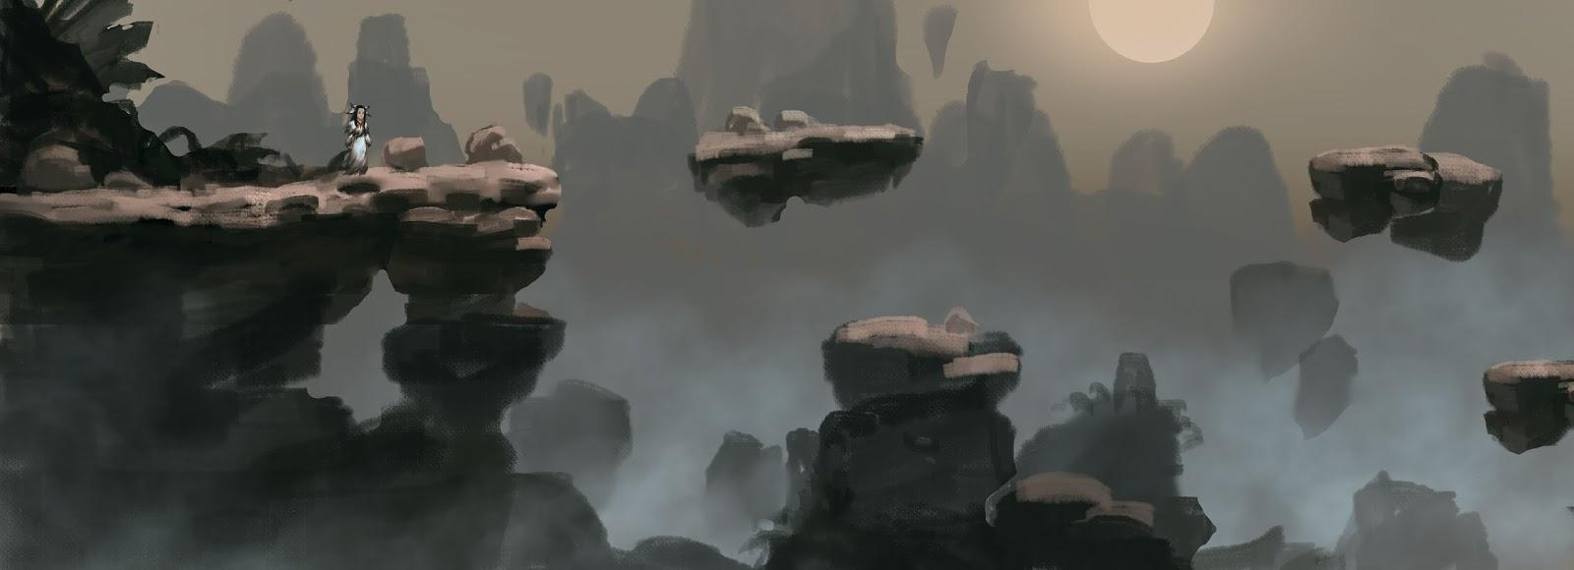 Mechanics:

-left and right arrow keys to move back and forth around the map

-space bar to jump

-f key to turn into wolf